UNITED STATES
SECURITIES AND EXCHANGE COMMISSION
Washington, D.C. 20549
__________________________________________
FORM 8-K

CURRENT REPORT
Pursuant to Section 13 OR 15(d) of The Securities Exchange Act of 1934

October 20, 2026
Date of Report (date of earliest event reported)
__________________________________________
MillerKnoll, Inc.
(Exact Name of Registrant as Specified in Charter)
Michigan |  |  | 001-15141 |  |  | 38-0837640
(State or Other Jurisdiction of Incorporation) |  |  | (Commission File Number) |  |  | (I.R.S. Employer Identification No.)

855 East Main Avenue
Zeeland, MI 49464
(Address of principal executive offices and zip code)
(616) 654-3000
(Registrant's telephone number, including area code)

Not Applicable
(Former Name or Former Address, If Changed Since Last Report)
__________________________________________

Check the appropriate box below if the Form 8-K filing is intended to simultaneously satisfy the filing obligation of the registrant under any of the following provisions:

☐ Written communications pursuant to Rule 425 under the Securities Act (17 CFR 230.425)
☐ Soliciting material pursuant to Rule 14a-12 under the Exchange Act (17 CFR 240.14a-12)
☐ Pre-commencement communications pursuant to Rule 14d-2(b) under the Exchange Act (17 CFR 240.14d-2(b))
☐ Pre-commencement communications pursuant to Rule 13e-4(c) under the Exchange Act (17 CFR 240.13e-4(c))

Securities registered pursuant to Section 12(b) of the Act:
Title of each class |  |  | Trading Symbol(s) |  |  | Name of each exchange on which registered
Common Stock, par value $0.20 per share |  |  | MLKN |  |  | Nasdaq Global Select Market

Indicate by check mark whether the registrant is an emerging growth company as defined in Rule 405 of the Securities Act of 1933 (§230.405 of this chapter) or Rule 12b-2 of the Securities Exchange Act of 1934 (§240.12b-2 of this chapter).

Emerging growth company ☐

If an emerging growth company, indicate by check mark if the registrant has elected not to use the extended transition period for complying with any new or revised financial accounting standards provided pursuant to Section 13(a) of the Exchange Act. ☐

Item 5.02 Departure of Directors or Certain Officers; Election of Directors; Appointment of Certain Officers; Compensatory Arrangements of Certain Officers

Appointment of Mr. Stutz as Chief Executive Officer and to the Board

On October 21, 2026, MillerKnoll, Inc. (the “Company”) announced that its Board of Directors (the “Board”) has appointed Jeffrey M. Stutz, age 55, as Chief Executive Officer and as a member of the Board, in each case effective as of such date (the “Start Date”). Mr. Stutz’s service as the Company’s Interim Chief Executive Officer concluded on the same date.

Prior to his appointment as Interim Chief Executive Officer in June 2026, Mr. Stutz served as Chief Operating Officer of the Company from September 2025, overseeing the International Contract Business, global manufacturing and distribution operations, and the Company’s Europe-based brands, including HAY, Muuto, Colebrook Bosson Saunders (CBS), and NaughtOne. Previously, Mr. Stutz served as the Company's Chief Financial Officer, a position he assumed in 2015, managing all aspects of global financial operations for the Company for over ten years. Mr. Stutz joined Herman Miller in 2001 as Manager of Consolidations and External Reporting. In subsequent years, he served in a range of finance leadership positions, including Vice President of Investor Relations, Corporate Treasurer, and Chief Accounting Officer. Mr. Stutz also served as President of the Geiger and DatesWeiser furniture brands. Mr. Stutz holds a B.A. in Accounting from Michigan State University, and an MBA from Grand Valley State University.

In connection with the appointment of Mr. Stutz to the Board, the Board increased the size of the Board from ten to eleven members.

Offer Letter with Mr. Stutz

In connection with Mr. Stutz’s appointment as Chief Executive Officer, the Company entered into an offer letter with Mr. Stutz, dated October 20, 2026, which sets forth the material terms of his employment and compensation. Pursuant to the offer letter, effective as of the Start Date, Mr. Stutz will receive an annual base salary of $1,000,000 and will be eligible to participate in the Company’s annual incentive plan and long-term incentive plan, with target opportunities equal to 125% and 400% of his base salary, respectively.

To reflect Mr. Stutz’s promotion to Chief Executive Officer and the increase in his target annual long-term incentive opportunity, the offer letter also provides for a one-time “step-up” equity grant with an aggregate target grant date value of $1,075,000, representing the difference between the target grant date value of his July 2026 annual equity grant and his new annual target grant value. The step-up grant will be delivered 60% in performance stock units and 40% in restricted stock units under the Company’s 2026 Long-Term Incentive Plan, under the standard grant agreements applicable to other senior executives, as soon as administratively practicable after the Start Date.

The offer letter also provides that, if Mr. Stutz’s employment is terminated by the Company without cause or by Mr. Stutz for good reason, in each case other than within two years following a change in control of the Company, Mr. Stutz will be entitled, subject to his execution and non-revocation of a release of claims, to 18 months of base salary continuation and 18 months of benefits continuation.

In connection with his promotion, Mr. Stutz’s existing Management Continuity Agreement with the Company was also amended, effective as of the Start Date, to increase the cash severance multiple from two times to three times and extend the benefits continuation period from 24 months to 36 months, in each case upon a qualifying termination of Mr. Stutz’s employment within two years following a change in control of the Company, consistent with the change-in-control severance terms that applied to the Company’s former Chief Executive Officer, as described in the Company’s definitive proxy statement filed with the U.S. Securities and Exchange Commission on August 29, 2025.

The foregoing description of the offer letter is qualified in its entirety by reference to the full text of the offer letter, a copy of which is filed as Exhibit 10.1 to this Current Report on Form 8-K and incorporated herein by reference.

There are no arrangements or understandings between Mr. Stutz and any other persons pursuant to which Mr. Stutz was selected as Chief Executive Officer or Director, and there are no transactions between Mr. Stutz and the Company that would be reportable under Item 404(a) of Regulation S-K. Mr. Stutz has entered into the Company’s standard form of indemnification agreement, a copy of which is filed as Exhibit 10.18 to the Company’s Annual Report on Form 10-K filed with the Securities and Exchange Commission on July 26, 2022.

Item 7.01 Regulation FD Disclosure

A copy of the press release issued by the Company on October 21, 2026 regarding the appointment of Mr. Stutz as Chief Executive Officer and to the Board is furnished as Exhibit 99.1 to Current Report on Form 8-K.

This information shall not be deemed “filed” for purposes of Section 18 of the U.S. Securities Exchange Act of 1934 (the “Exchange Act”), or incorporated by reference in any filing under the Securities Act of 1933, as amended, or the Exchange Act, except as shall be expressly set forth by specific reference in such a filing.

Item 9.01 Financial Statements and Exhibits

(d) Exhibits.

Exhibit No. |  |  | Description
10.1 |  |  | Offer Letter, dated October 20, 2026, between MillerKnoll, Inc. and Jeff Stutz.
99.1 |  |  | Press release, dated as of October 21, 2026.
104 |  |  | Cover Page Interactive Data File (embedded within the Inline XBRL document).

SIGNATURE

Pursuant to the requirements of the Securities Exchange Act of 1934, the registrant has duly caused this report to be signed on its behalf by the undersigned thereunto duly authorized.
Date: |  |  | October 21, 2026 |  |  |  |  |  | MillerKnoll, Inc.
 |  |  |  |  |  |  |  |  | By: |  |  | /s/ Kevin J. Veltman
Kevin J. Veltman
Chief Financial Officer

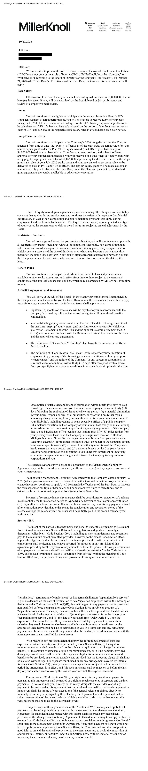

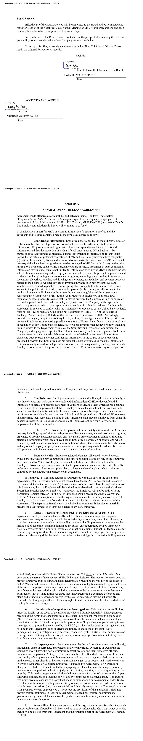

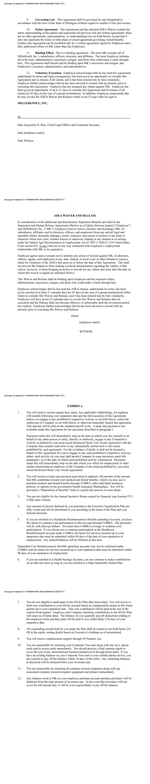

MillerKnoll Appoints Jeff Stutz as Chief Executive Officer

ZEELAND, Mich., October 21, 2026 — MillerKnoll, Inc. (“MillerKnoll” or the “Company”) (NASDAQ: MLKN), a growth-oriented small-cap value company in the industrial and consumer sectors, announced today its Board of Directors (“Board”) has unanimously appointed Jeff Stutz as Chief Executive Officer and a member of the Board, effective immediately. Stutz has served as Interim Chief Executive Officer since June 30, 2026.

“Jeff brings deep institutional knowledge, broad industry experience, and a proven record of leadership at MillerKnoll, and the Board has full confidence in his ability to drive long-term shareholder value,” said John R. Hoke III, Chairman of the Board. “As Interim CEO, Jeff has made an immediate and meaningful impact by driving stronger operating income, margins and earnings. Following a rigorous search process, the Board believes Jeff is the right leader for MillerKnoll as we continue to focus on accelerating sales, improving profitability and creating value for our shareholders.”

“This is a pivotal time for MillerKnoll, and I am energized by the opportunity to continue working with our talented teams and iconic brands across the Company as we focus on elevating our performance and creating long-term value,” said Mr. Stutz. “Serving as Interim CEO over the past few months, I have been working even more closely with our teams, customers and partners around the globe, reinforcing my conviction in our strengths and upside potential. I look forward to partnering with the Board and our teams to sharpen our priorities, manage costs with discipline, strengthen our balance sheet and build on our foundation to deliver for our shareholders, customers and associates.”

About Jeff Stutz

Mr. Stutz has more than 25 years of leadership experience in the design and manufacturing industry. He served as Chief Operating Officer from September 2025 to June 2026, overseeing the Company’s International Contract segment, global manufacturing operations, and European-based brands including HAY, Muuto, Colebrook Bosson Saunders (CBS), and NaughtOne. Previously, he served as Chief Financial Officer for more than 10 years, leading MillerKnoll’s global financial operations and helping guide the Company through periods of macroeconomic challenge and opportunistic growth.

Mr. Stutz joined Herman Miller in 2001 and held several finance leadership roles before becoming CFO, including Vice President of Investor Relations, Corporate Treasurer, and Chief Accounting Officer.

He holds a Bachelor’s degree in Accounting from Michigan State University and an MBA from Grand Valley State University.

Forward-Looking Statements

This communication includes forward-looking statements within the meaning of Section 27A of the Securities Act of 1933 and Section 21E of the Securities Exchange Act of 1934. Forward-looking statements include, but are not limited to, statements regarding future events, anticipated results of operations, our expectations regarding future market conditions, our business strategies, our assessment of risks we face, and other aspects of our operations or operating results. These forward-looking statements generally can be identified by phrases such as “will,” “expects,” “anticipates,” “foresees,” “forecasts,” “estimates” or other words or phrases of similar import. It is uncertain whether any of the events anticipated by the forward-looking statements will transpire or occur, or if any of them do, what impact they will have on our results of operations or financial condition or the price of our stock. These forward-looking statements involve certain risks and uncertainties, many of which are beyond our control, that could cause actual results to differ materially from those indicated in such forward-looking statements, including, but not limited to:

•The effects of the ongoing conflict in the Middle East and broader geopolitical instability, including negative impacts on our supply chain, decreased sales within the region or beyond due to supply chain constraints or other factors, energy prices, and broader inflationary and macroeconomic effects;

•Changes to U.S. and international trade policies, including new or increased tariffs, developments relating to tariff refunds (including the risk of clawback or reversal of tariff refunds or the discontinuation of any additional tariff refunds), and changing import/export regulations, which impact both the cost and availability of materials and components used to manufacture our products as well as demand for our products;

•Challenges in implementing our growth strategy and the possibility that the assumptions on which that strategy was built prove inaccurate;

•Consumer spending levels, which have a significant impact on demand for our products within our Global Retail segment;

•Global and national economic conditions such as heightened inflation, uncertainty regarding future interest rates, foreign currency exchange rate fluctuations, geopolitical instability, and potential governmental responses to these events;

•Cybersecurity threats and risks;

•Public health crises, such as pandemics and epidemics, and governmental policies and actions to protect the health and safety of individuals or to maintain the functioning of national or global economies;

•Risks related to the additional debt incurred in connection with our acquisition of Knoll, including increased interest expense, our ability to comply with our debt covenants and obligations, and limitations on certain business activities imposed by our credit agreement;

•Availability and pricing of raw materials;

•Financial strength of our dealers and customers;

•Pace and level of government procurement; and

•Outcome of pending litigation or governmental audits or investigations.

The foregoing list of important factors is not exhaustive. For additional information about other factors that could cause actual results to differ materially from those described in the forward-looking statements, please refer to MillerKnoll’s periodic reports and other filings with the SEC, including the risk factors identified in MillerKnoll’s most recent Annual Report on Form 10-K for the fiscal year ended May 30, 2026, as updated by subsequent Quarterly Reports on Form 10-Q. The forward-looking statements included in this communication are made only as of the date hereof. MillerKnoll does not undertake any obligation to update any forward-looking statements to reflect subsequent events, new information, or changes in circumstances, except as required by law.

About MillerKnoll

MillerKnoll is a collective of dynamic brands that comes together to design the world we live in. The MillerKnoll brand portfolio includes Herman Miller, Knoll, Colebrook Bosson Saunders, Design Within Reach, Edelman, FilzFelt, Geiger, HAY, HOLLY HUNT, Knoll Textiles, Maharam, Muuto, NaughtOne and Spinneybeck. Guided by a shared purpose—design for the good of humankind—MillerKnoll generates insights, pioneers innovations and champions ideas to better align spaces with how people live, work and gather. For more information, visit millerknoll.com.

For further information:
Investors: investor@millerknoll.com
Media: media_relations@millerknoll.com

